The following practice test link is provided for all 2022 – 2023 registered and PAID members of Illinois DECA. The student testing population will be updated every Sunday evening to enable newly paid Illinois DECA members access to the practice tests. This site will be available until the start of ICDC in April. When you access the following hyperlink, https://practice.answerwrite.com/deca/il-p in you web browser, you will see the following.
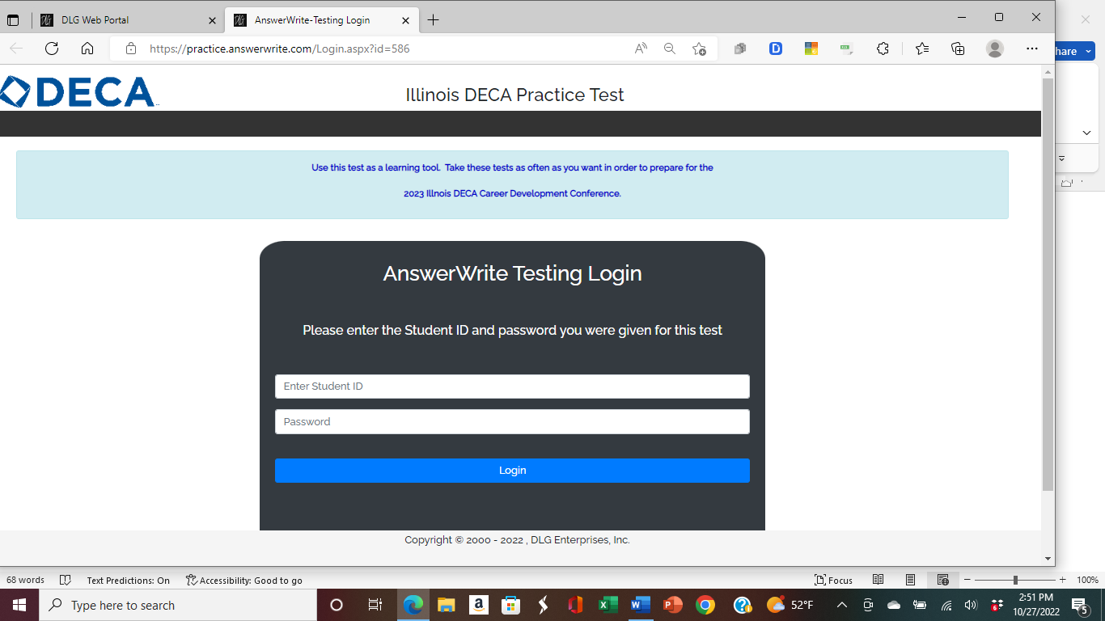

It is the responsibility of the Chapter Advisor to provide his/her students with their DECA Student ID number. The password is ILLINOIS

